Use Case Diagram

Play Game

User1

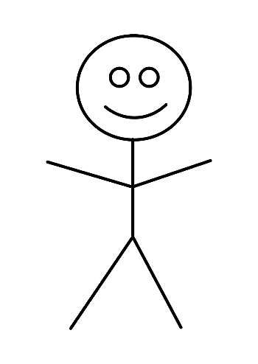

Take a piece

Make a move

Win or lose a

game

User2